**Appendix 1: Assignment submission cover sheet**

**ASSIGNMENT SUBMISSION COVER SHEET**

|  |
| --- |
| **Cse23-126** |

**Student Id:**

|  |
| --- |
| **Lebopo Mogorosi** |

**Student names:**

|  |
| --- |
| **Cse23-126@thuto.bac.ac.bw** |

**Student email:**

|  |
| --- |
| **Cse5** |

**Cohort:**

|  |
| --- |
| **Web & Multimedia Design** |

**Assignment title:**

|  |
| --- |
| **18 November 2024** |

**Date of submission:**

|  |
| --- |
| **BSc (Hons) Computer Systems Engineering** |

**.**

**Programme of Study:**

|  |
| --- |
| **Year 1** |

**Year of Study:**

**Intellectual property statement**

**By checking the box below, I certify that this assignment is my own work and is free from plagiarism. I understand that the assignment may be checked for plagiarism by electronic or other means and may be transferred and stored in a database for the purposes of data-matching to help detect plagiarism. The assignment has not previously been submitted for assessment in any other unit or to any other institution. I**

**have read and understood the Botswana Accountancy College plagiarism guidelines policy.**

**☐ Agree Signature……L.Mogorosi…….………….**

**Date……28 May 2025…………………….**

**WEBSITE SPECIFICATIONS**

The objective of the StellarBeingsCo website is to display and promote handcrafted and stylish jewellery products especially those with naturally found resources on a digital catalogue platform. The platform allows customers to explore collections, view product images on the gallery and send purchase inquiries and feedback. The site also aims to establish the brands presence online with a simple, clean and modern interface.

Our business goals are as follows:

* Establish and strengthen brand online presence.
* Allow easy browsing and purchase of products.
* Create a customer friendly, engaging and responsive experience on all devices.
* Support future e-commerce integration.

Our target audience is a demographic of individuals and groups of ages between 18 and 50 of all genders, with a primary focus on women. A demographic of young professionals, fashion-conscious individuals and gift shoppers will be our target area. These groups of people are more mobile-savvy, familiar with the use of smart devices and basic online browsing and interactions,

The type of website this is, is a product catalogue website with interactive features and a strong visual identity. At current it does not support real-time transactions, it includes a “Add to Cart” functions and a feedback form, simulating typical e-commerce behaviour.

**INFORMATION DESIGN AND TAXONOMY**

**Site Architecture Overview-** the website uses a clear and consistent structure with the navigation being easy to use. Following the “three-click” rule, it ensures that the users can access any content within three steps. The main pages include:

* Home- hero-banner + featured items.
* Shop- interactive product catalogue.
* Gallery- visual product images and inspiration
* About Us- our brand story and mission.
* Contact Us- feedback form where users can gain contact with the admins and service desk.
* My Cart- basic cart simulation where product purchases are compiled and reviewed before final checkout.

**Site Map**

**Storyboard Summary:**

Each page is linked via a navigation bar with a clear call-to-action (“Shop Now”) from the home banner. The structure promotes ease of use and visual storytelling.

**PAGE TEMPLATE DESIGN**

**Template Elements:**

All pages share a similar and consistent layout structured as follows:

* Header with logo and nav bar.
* Main content section.
* Footer with social media and copyright.

**Homepage Layout Highlights:**

* Full-screen horizontal banner slider.
* “Shop Now” button overlay that redirects to the Shop page.
* Product-grid under the banner.
* Responsive adjustments via Flex/Grid layout.

**Wireframe and Flowchart**

**TECHNICAL BRIEF**

The development tools used were:

* HTML5 & CSS3: used to design the core layout and styling of the website.
* JavaScript: Used to design banner slider, add to cart and mobile navigation functions.
* VS Code: Main IDE for coding.
* FIGMA: used for image editing for the logo and banners.
* Git & GitHub Pages: a version control and host for the website.

The site was built using semantic HTML and responsive CSS practices. JavaScript was used for domain manipulation, lightbox functionality and user interactions like the cart simulation. All elements and assets are stored in an organized folder structure for easy reference and scalability.

**QUALITY ASSURANCE**

**PUBLISHING AND PROMOTION**

**Hosting:**

The StellarBeingsCo website was hosted using GitHub Pages, which is a recommended, reliable and free platform for all front-end projects. All files inclusive of the HTML, CSS, images and scripts were uploaded to a GitHub repository created specifically for the project.

**GitHub Pages Setup:**

* A GitHub repository was created and named cse23-126.
* Initialized the repository with a README filr.
* Cloned the repository to a local machine using git clone <https://github.com/lebopomogorosi/cse23-126.git>.
* Added website files using:

git add .

git commit -m “Initial website upload”

git push origin main

* GitHub Pages was enabled in the repository settings by choosing the root directory as the source.
* The live site was then finally copied and tested.
* The live website URL is: <https://lebopomogorosi.github.io/cse23-126/>.
* Website on Chrome:

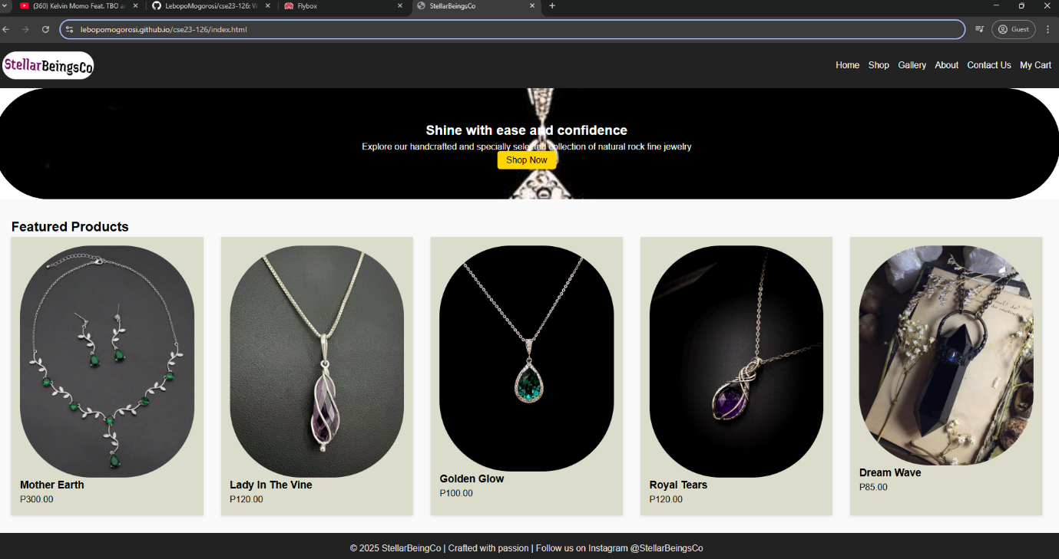

* Website on Explora

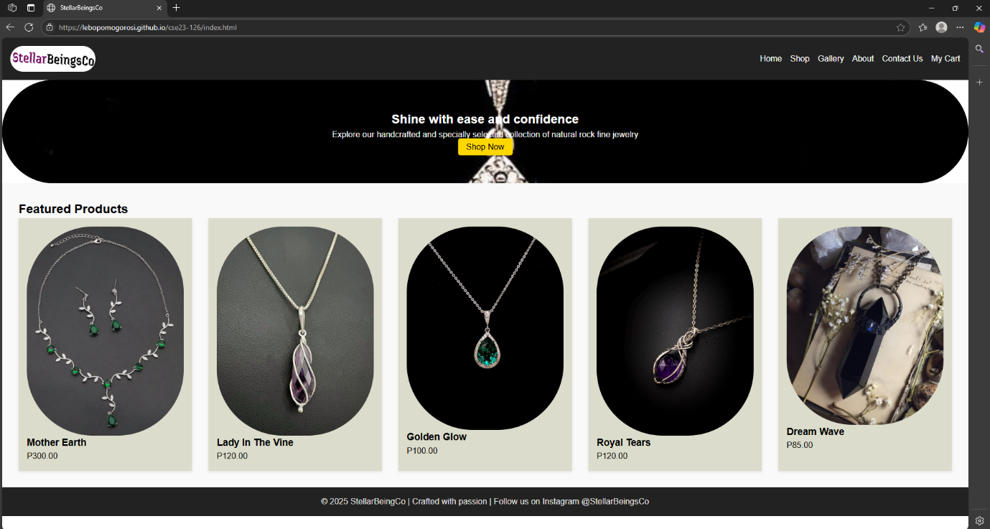

* Website on Iphone

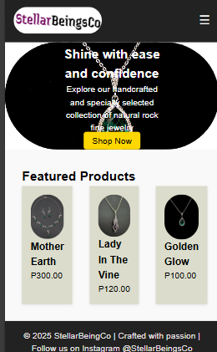

* Website on Asus ZenBook Fold

**FUTURE DEVELOPMENTS/ RECOMMENDATIONS**

To enhance the user experience and functionality of the website in the future, the following developments are recommended:

* Full e-commerce integration: adding a real-time shopping cart and checkout functionality using payment gateways like PayPal or OrangeMoney or Visa applications.
* User Accounts: enabling customers to register and login to the website allowing them to monitor and track their orders and shopping history.
* Search & Filter: implementing product filters by category, material or price for a better browsing experience.
* Product Reviews: adding a review section to build social trust amongst users.
* Mobile App Integration: Extending the website capabilities into mobile-friendly apps.